1. Get bus.sql from Moodle and import it into MySQL.

2. How are the tables in the database related?

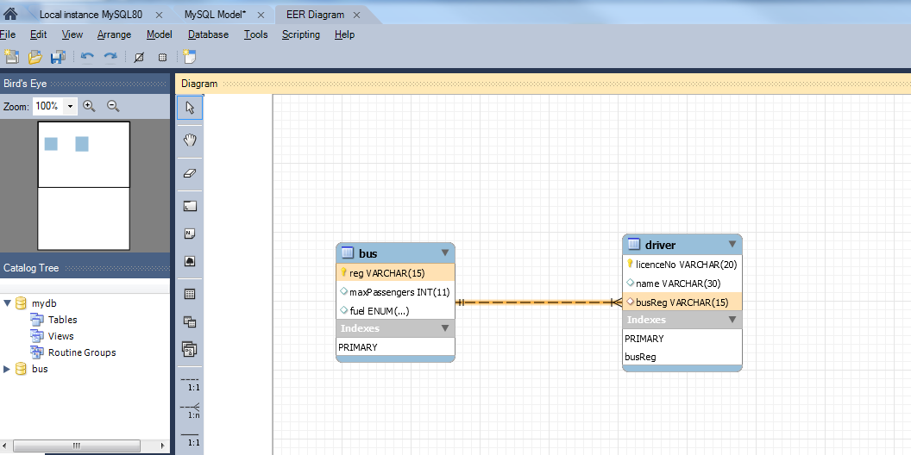

3. Add the following drivers: “Mary” “Bob” – licence number “RN2423” “Sean” – licence number “FF88345” who drives bus “191-G-123” What happens and why?

Cant add Mary as no licenceNo as this cannot be null

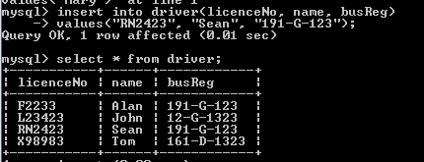

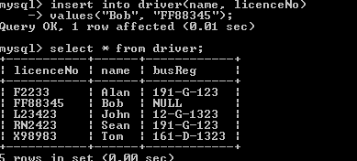

4. Add the following buses: "12-G-1323" that can hold up to 34 passengers and runs on "Diesel" "171-G-885" that can hold up to 84 passengers and runs on "Petrol" "191-D-45890" that can hold up to 120 passengers and runs on "Ethanol" What happens and why?

Error- Ethanol not a valid option for fuel- only diesel, electric or petrol.

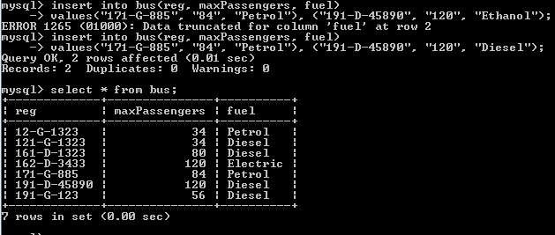

5. Update driver’s licences that contain the letters “F” or “R” to have the letters “T-“ before their current licence number.

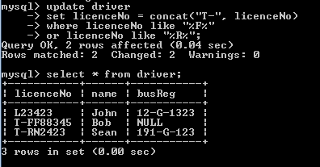

6. Delete driver “Alan”. What happens and why?

Alan was deleted from the driver table, but his bus 191-G-123 is still on the bus table

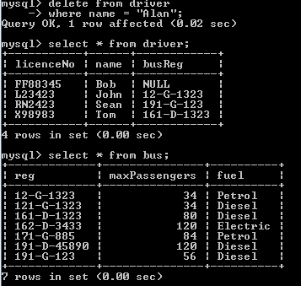

7. Delete bus “161-d-1323”. What happens and why?

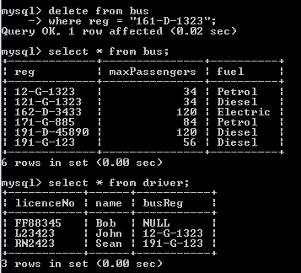

The record has been deleted from both the bus table and the driver table

Reg field set to ‘On Delete Cascade’ meaning that when deleted remove from other tables, even though sql did not state that it had updated the bus table

8. Get bus2.sql from Moodle and import it into MySQL. To use this database type use bus2;

9. Delete bus “161-d-1323”. What happens and why?

Record is deleted from both the bus table, but set the busReg record to Null in the driver table. The driver table the reg field is set to ‘On Delete set Null’

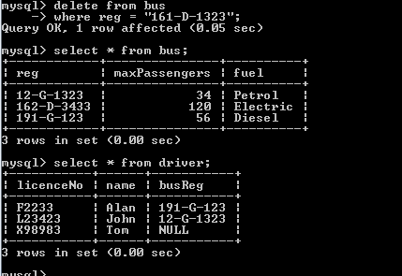

10. Get employees2.sql from Moodle and import it into MySQL. To use this database type use employees2;

11. Show the emp_no, first_name and last_name of employees born in the average year. The average year should be rounded down to the nearest whole number. For example,

• 1949.1 becomes 1949.

• 1949.9 becomes 1949.

• 1949.0 becomes 1949.

Use floor to get sql to round down.

Also the indentation was a function within the statement

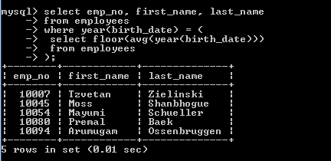

12. Show the emp_no, first_name, last_name and name of the department each employee is in.

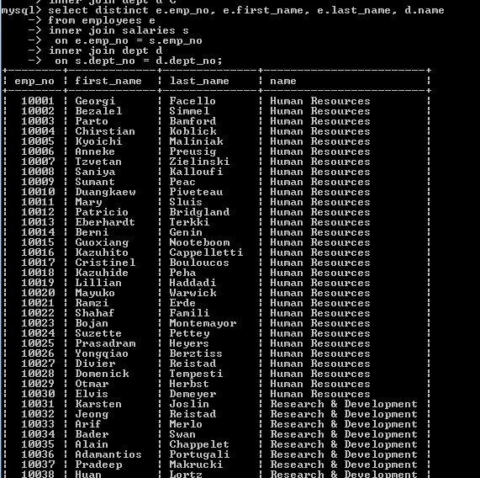

The TABLES

